**Software Design Specification**

**Project:Chatbot For Mutual Fund Website**

**Prepared By:**

Mohit Kumar(U101116FCS250)

Purandhar Chilukuru(U101116FCS2723)

Vaishnavi Kattekola(U101116FCS270)

Vaibhav Singh(U101116FCS268)

Sarthak Tripathi(U101116FCS110)

Table of Contents  
1. Introduction Error! Bookmark not defined.  
1.1 Purpose of this document Error! Bookmark not defined.  
1.2 Scope of the development project Error! Bookmark not defined.  
1.3 Definitions, acronyms, and abbreviations Error! Bookmark not defined.  
1.4 References Error! Bookmark not defined.  
1.5 Overview of document Error! Bookmark not defined.  
2. Conceptual Architecture/Architecture Diagram Error! Bookmark not defined.  
2.2 Structure and relationships Error! Bookmark not defined.  
2.3 User interface issues Error! Bookmark not defined.  
3. Logical Architecture (Class Diagram, Sequence Diagram, State Diagram)Error! Bookmark not de  
3.1 Logical Architecture Description Error! Bookmark not defined.  
3.2 Class name: Login Error! Bookmark not defined.  
3.3 Class Name: Adminlanding Error! Bookmark not defined.  
3.4 Class Name: Studentlanding Error! Bookmark not defined.  
3.5 Class Name: Notification Error! Bookmark not defined.  
3.6 Class Name: Training_Admin Error! Bookmark not defined.  
3.7 Class Name: FilePath Error! Bookmark not defined.  
3.8 Class Name: Training_Student Error! Bookmark not defined.  
3.9 Class Name: PdfAdapter Error! Bookmark not defined.  
3.10 Class Name: StudentAccount Error! Bookmark not defined.  
3.11 Class Name: JobListings Error! Bookmark not defined.  
3.12 Class Name: ViewProfile_Student Error! Bookmark not defined.  
3.13 Class Name: ViewProfile_Admin Error! Bookmark not defined.  
3.14 Class Name: StudentAbout Error! Bookmark not defined.  
3.15 Class Name: AdminAbout Error! Bookmark not defined.  
3.16 Class Name: StudentFAQ Error! Bookmark not defined.  
3.17 Class Home Error! Bookmark not defined.  
3.18 Class name: Student Landing Error! Bookmark not defined.  
3.19 Class name: FAQ (Admin) Error! Bookmark not defined.  
4.0 Execution Architecture Error! Bookmark not defined.  
4.1 Reuse and relationships to other products Error! Bookmark not defined.  
5.0 Design decisions and tradeoffs Error! Bookmark not defined.  
6.0 Pseudocode for components

**The Software Design Specification**  
   
***1. Introduction***  
The Software Design Document is a document to provide documentation which will be used to aid in software development by providing the details for how the software should be built. Within the Software Design Document are narrative and graphical documentation of the software design for the project including use case models, sequence diagrams, collaboration models, object behaviour models, and other supporting requirement information.  
  
***1.1 Purpose of this document***This document will define the design of the one runway simulator. It contains specific information about the expected input, output, classes, and functions. The interaction between the classes to meet the desired requirements are outlined in detailed figures at the end of the document.  
  
***1.2 Scope of the development project***  
We describe what features are in the scope of the software and what are not in the scope of the software to be developed.  
  
**In Scope:**  
a. Chat-bot for a financial based company Innovative Financial  
b. Users can retrieve the information about their investments  
c. Check their transaction details (mutual fund & SIP)  
d. Ask any queries/ suggestions regarding investments  
e. See market status and analyze customers market status  
**Out of Scope:**  
a. User cannot suggest answers to the Bot  
b. Bank transactions are not included in transactions  
c. payments are not under scope  
***1.3 Definitions, acronyms, and abbreviations***   
 IEEE SDS : Institute of Electrical and Electronics Engineers SDS  
Software Design Specification   
NSE (National Stock Exchange): Demutualized electronic exchange in the country

***1.4 References***  
1.4.1 R. S. Pressman, Software Engineering: A Practioner’s Approach, 5th Ed, McGraw-Hill, 2001.  
  
1.4.2 IEEE SDS template  
  
  
  
***1.5 Overview of document***  
This SDS is divided into seven sections with various sub-sections. The sections of the Software Design Document are:  
  
1. Introduction: describes about the document, purpose, scope of development project definitions and abbreviations used in the document.  
2. Conceptual Architecture/Architecture Diagram: describes the overview of components, modules, structure and relationships and user interface issues.  
   
3. Logical Architecture: describes Logical Architecture Description and Components.  
4. Execution Architecture: defines the runtime environment, processes, deployment view.  
5. Design Decisions and Trade-offs: describes the decisions taken along with the reason as to why they were chosen over other alternatives.  
6. Pseudocode for components: describes pseudocode, as the name indicates.  
7. Appendices: describes subsidiary matter if any.  
 ***2. Conceptual Architecture/Architecture Diagram Architecture Diagram 1:***  
   
2.1 Overview of modules / components

NIL  
   
2.2Structure and relationships

NIL

***2.3 User interface issues***This section will address User Interface issues as they apply to the customers of innovative financials  
  
• User A is a unregistered customer, who has fair knowledge about investments and comfortable with technology. He is proficient with using most common computer applications.  
The Bot is very user-friendly and provides detailed description of steps regarding registration into the website, creating a profile. The customer is free to ask any questions regarding registration process and contact information of the Admin if required. He cannot access any other information rather than basic webpage details

• User B is a customer who is already registered.He might or might not be comfortable using android applications, the Chatbot is really user friendly and helpful in suggestions regarding investments and also analyses his account for better understanding of hi growth  
  
Since User B is a registered user he need not go through the registration process again and can directly login through his credentials which will be provided by the company it is imperative that he be given clear on-screen directions.Text size is reasonably larger and, therefore, more readable.The Bot has some frequently asked questions as option to choose. It is also multilingual. The Bot directly access to the google for the information. The information provided to this user is generic it is either from the bot’s database or from the google server. The admin might be questioned for any wrong details from database

• C is a the admin of the company who manages the database, credentials and account details of the users. He only has the complete access to the company's website and Bot’s database.He have the option of updating the Bot’s database regarding unanswered questions which are asked by the customer.The credentials of the unregistered customer are created by the admin. The profile of the user is created and maintained by the admin. The admin would be responsible for the information in the database he is the only one to edit or update database.

**3. Logical Data Flow Diagram (Class Diagram, Sequence Diagram, State Diagram)**

**3.1 Data Flow Diagram:**

Since we are not using OOP concept in our Chat bot software we are drawn a data flow diagram. 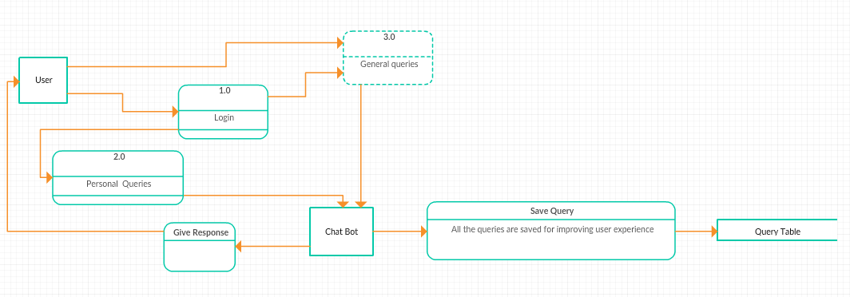

**3.2** **Sequence Diagrams**:

3.2.1 Sequence Diagram:Mutual Fund Values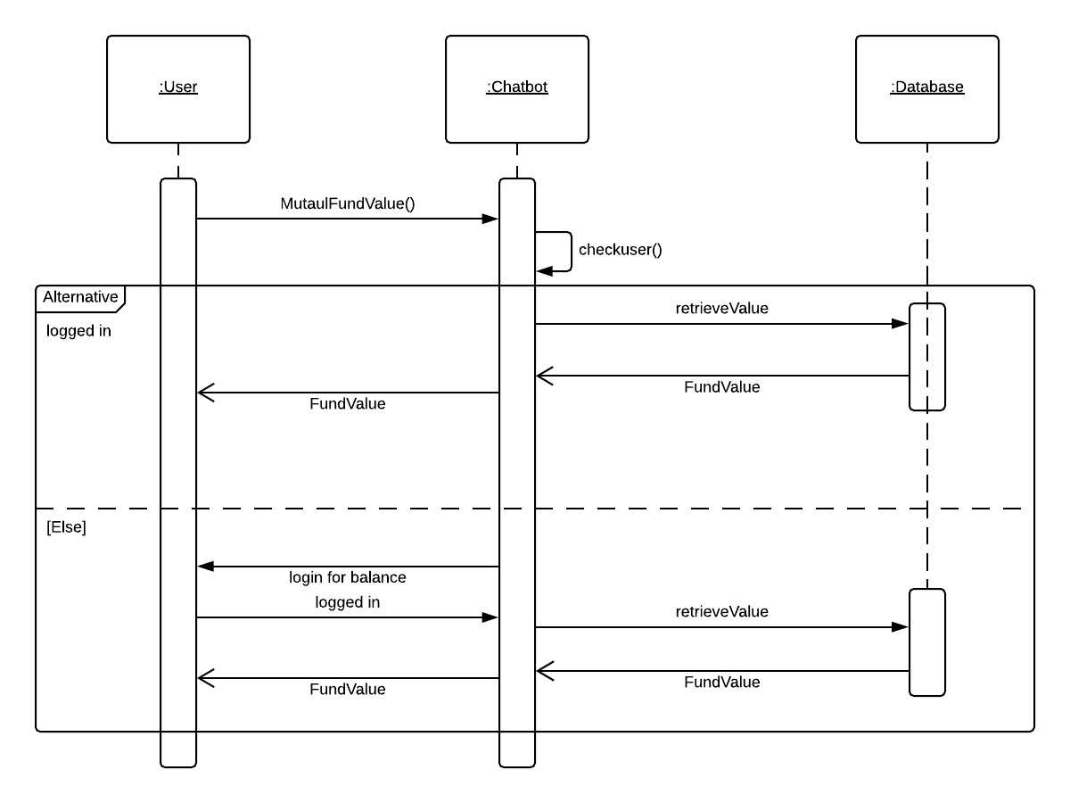

3.2.2 Sequence Diagram: Performance Portfolio Matrices  
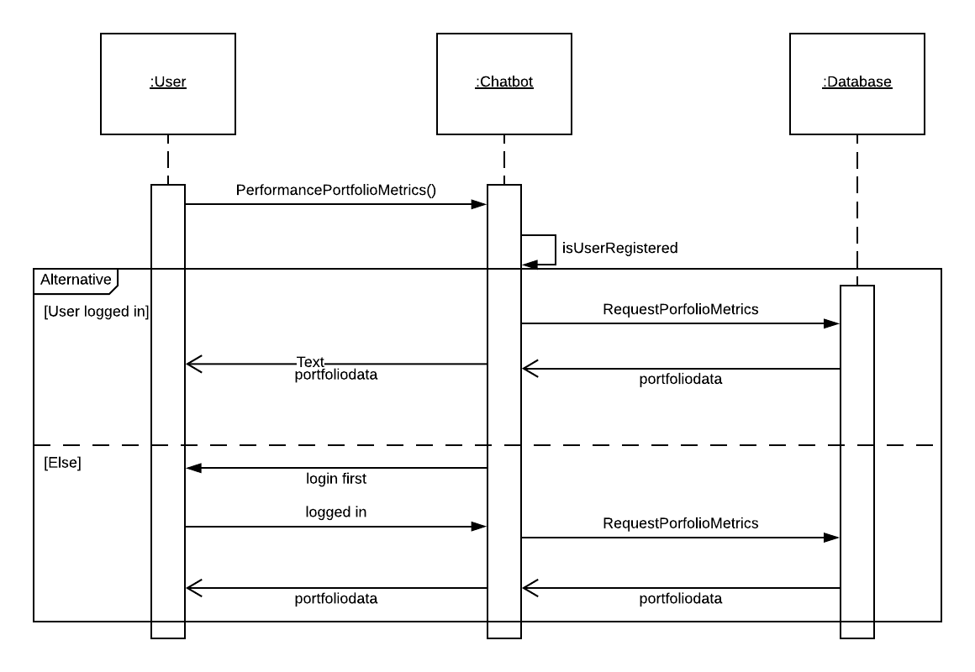

3.2.3 Sequence Diagram: Extract Transaction Status

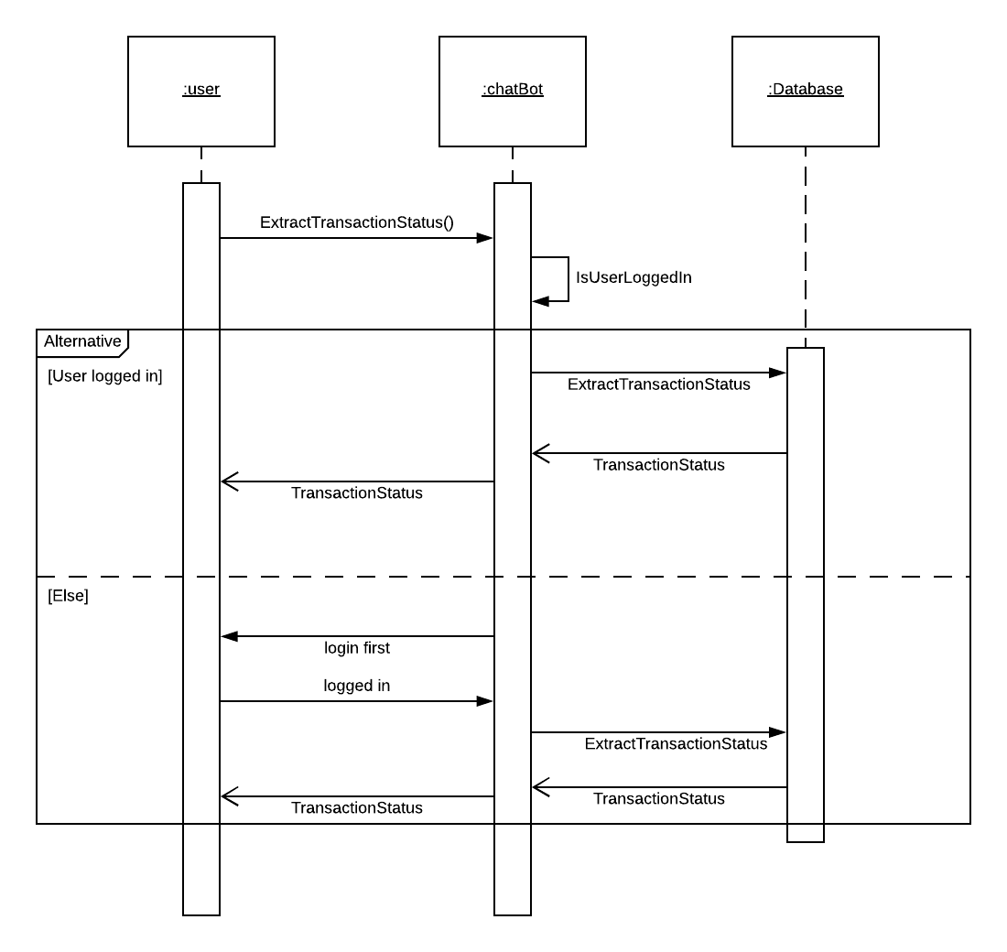

3.2.4 Sequence Diagram: Market Status  
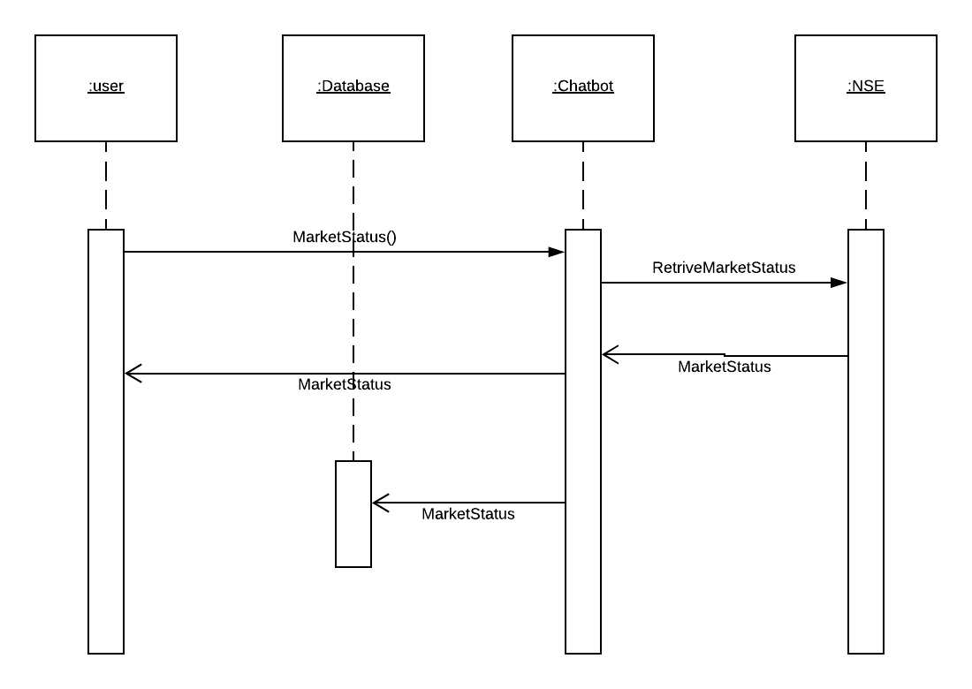

3.2.5 Sequence Diagram: Change Language

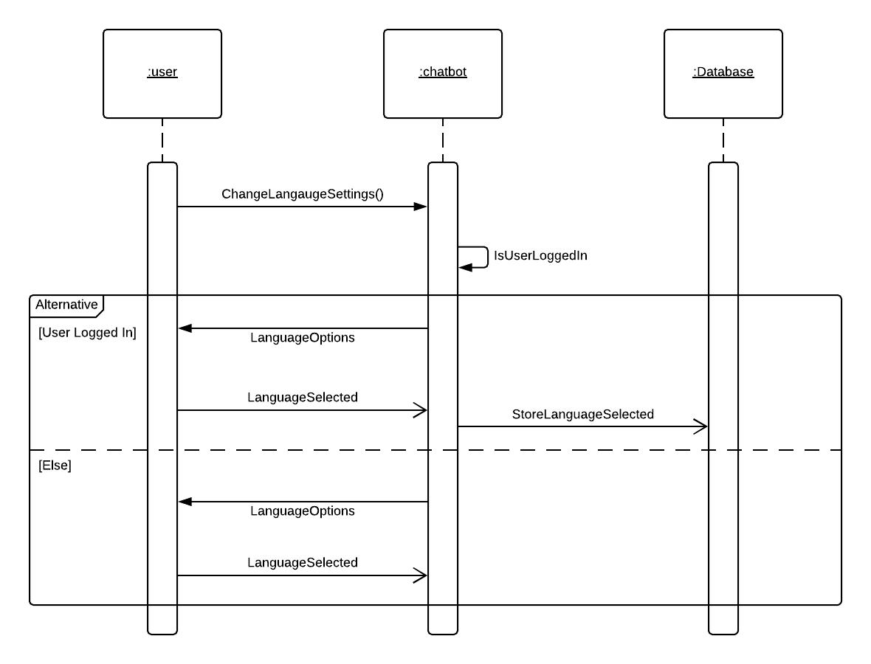

3.2.6 Sequence Diagram: Change Colour Settings

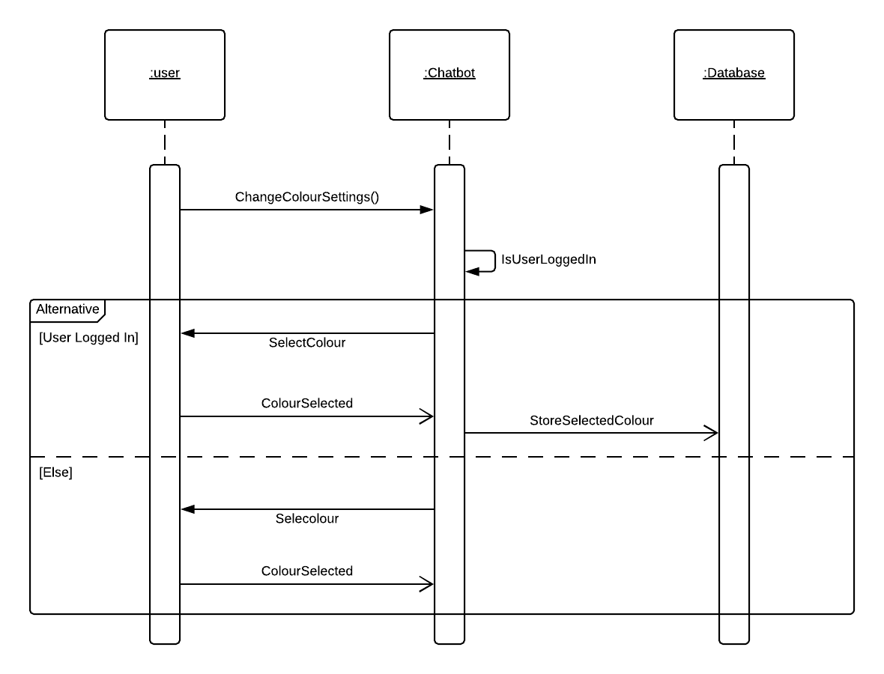

3.2.7 Sequence Diagram: KYC Links  
  
  
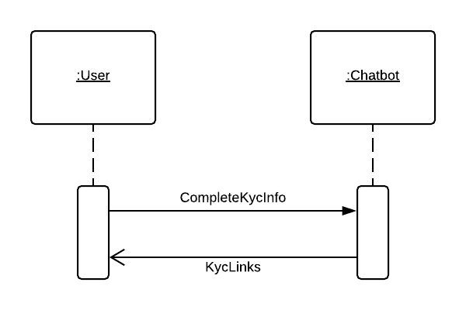

3.2.8 Sequence Diagram:General Queries

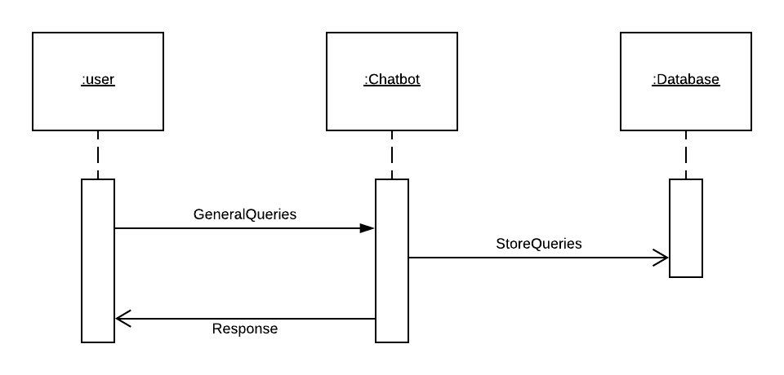

3.2.9 Sequence Diagram:Admin Side  
 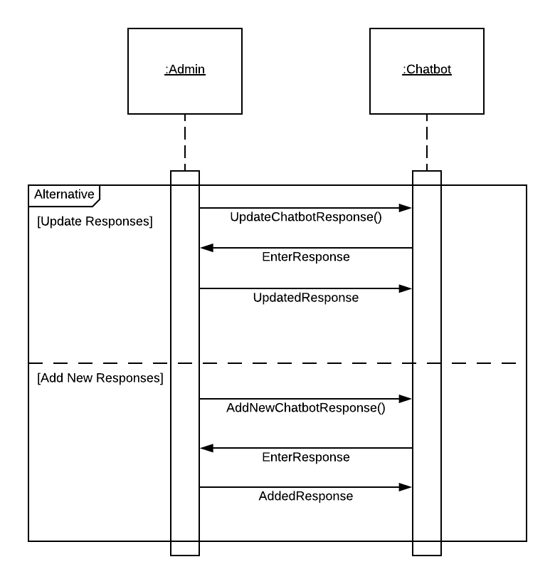

**State Diagrams:**

3.3.1 State Diagram: User Registration  
  
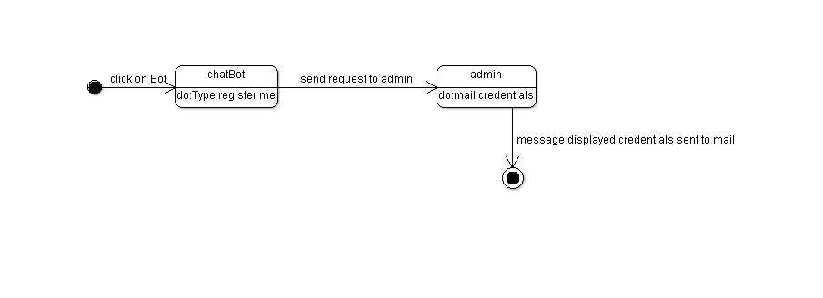

3.3.2 State Diagram: User Login  
  
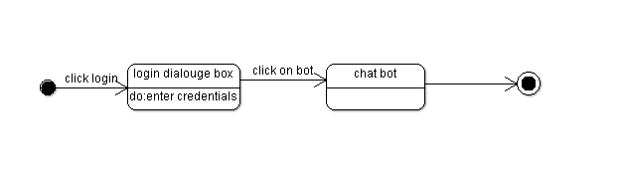

3.3.3 State Diagram:Change Language  
   
  
 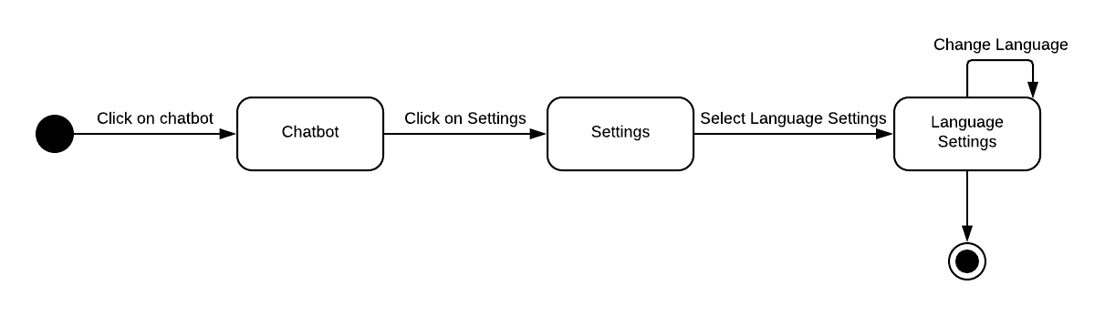

3.3.4 State Diagram: Admin Login:

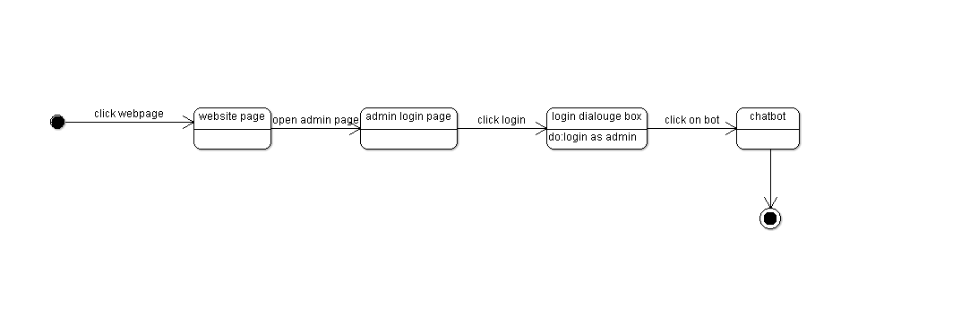

3.3.5 State Diagram: Add new Queries  
  
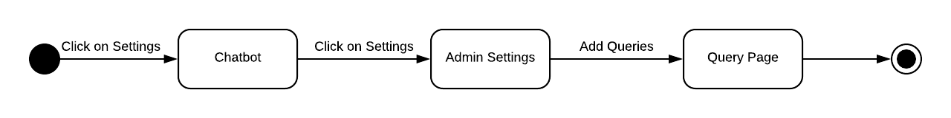

3.3.6 State Diagram: Edit response:

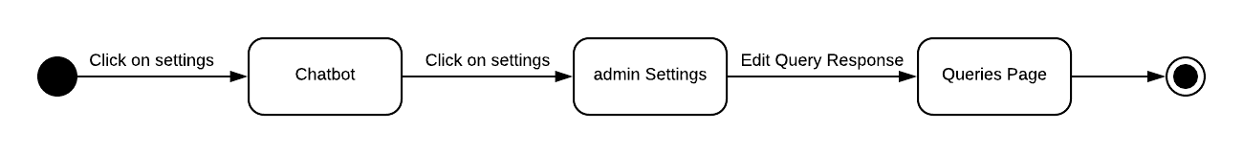

3.3.7 State Diagram: User Queries

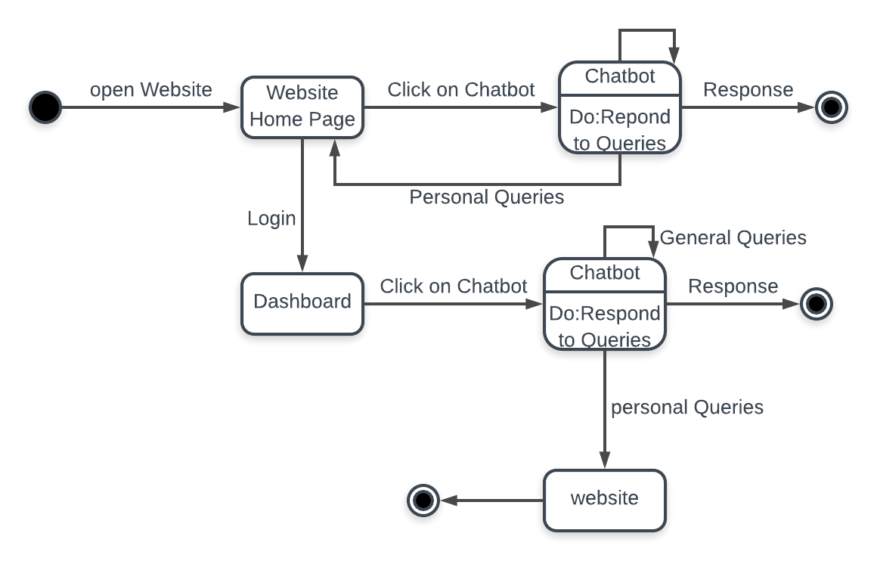

3.3.8 State Diagram: Admin Queries

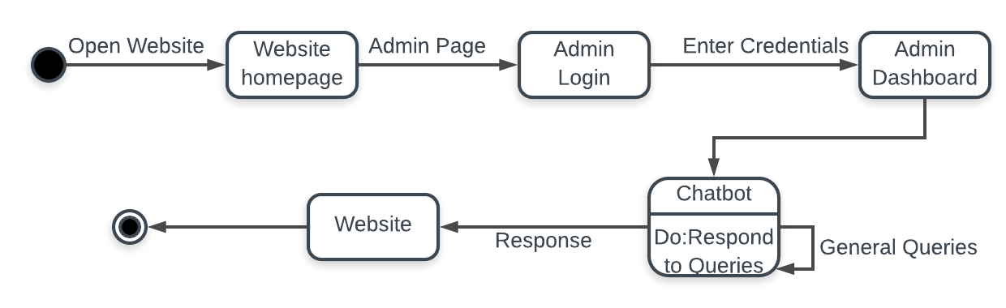

3.1 **Data Flow Diagram explanation**:  
It is easy to understand the flow of data through system with the right data flow diagram. DFD maps out the flow of information for any process

Gane and Sarson model of DFD is used here in which External entity is represented by rectangle, process are represented by rectangles with round corners data store by long short rectangles the dotted rectangle represents the control process.

User and cHat Bot are the entities(external). General queries is control process ,where as login and personal details are process. Save query and give response are data processes which are also a kind of process. Query table is a data store(files or repositories that hold information for later use)  
  
3.2 **Sequence Diagram:**  
  
 Filled Arrow line signifies there is a Synchronous message taken place. Response is being shown by an arrow with V head.  
  
3.2.1 **Mutual funds and values:** If the user asks the Chatbot regarding mutual fund value, the Chatbot checks the user details and verifies of the user is logged in or not. If logged in then Chatbot retrieves the fund values from the database. If not chatbot delivers an instruction to log in and then retrieves data after logged in  
  
3.2.2 **Performance portfolio metrics:** If user requests his performance analysis the chat bot repeats the same process of checking his registration and login information. If logged in the metrics are determined and sent to the user

3.2.3 **Extract transaction status:** If transaction status is requested and user is logged in the data is retrieved from database and is shown if not the chatbot waits for the user to log in and then sends data   
  
3.2.4 **Market status:** The market status is to be updated to the database from the NSE. When the user requests the information the chatbot it gets information from NSE and updates database along with sending information to user  
  
  
3.2.5 **Change Language settings**: if the user is logged in as a registered user and requests for change in language the bot offers options to change and stores the selected language as default language of that particular user in the database.  
   
3.2.6 **Change colour settings:** User can update colour of his choice as the default through this setting.

3.2.**7 KYC links** : If user asks for KYC information the bot responds with links from internet to complete process.  
  
3.2.8 **General Queries** : The general Queries regarding mutual funds and SIP the bot responds through internet and also saves the query and answer in its database for further usage.

3.2.9 **Admin** : Admin can add and update the answers of the unanswered questions to the database of Chatbot. The admin login enables the request to update responses and changes are made as suggested.  
  
3.3 **State Diagram**:  
  
Initial state is being shown by starting with a black dot. Final State is being shown by the black dot surrounded by an empty circle.  
  
3.3.1 **User registration** : As soon as the user clicks on the bot at right corner in the website and type register me the request is sent to admin and credentials are mailed to the user.

3.3.2 **User login** : The login dialog box displayed on the home page and the user enters his credentials to login as registered user.

3.3.3 **Change Language settings**: This state diagram shows how to change the language settings.

3.3.4 **Admin login**: The sequential steps for the admin to login his account.

3.3.5. **Add new queries**: When the admin logs in he can add new queries to the database.

3.3.6 **Edit response** : The answers for the questions in database can be altered or updated by the admin.

3.3.7 **User queries** : The general queries(for ex:what is SIP?) of the user can be viewed without logging into his account but if the user asks personal queries(for ex:my transaction history) then the chat bot will redirect the user to the website for login. After login,he will get the response for the query.

3.3.7 **Admin queries** :The admin will first visit the website and enter the admin mode then he will login using his credentials.After that,If the admin has general queries the chat bot will respond to it but for customer related queries(for ex:number of funds bought by the customers today) the chat bot will redirect the user to his response in the website.

**4.0 Execution Architecture**Runtime environment required is any device supporting internet access to the indimif official website   
4.1 Reuse and relationships to other products  
NIL  
  
**5.0 Design decisions and tradeoffs**  
  
The design decision to use two screens separately for admin and user is to provide encapsulation. It may have been possible to get all the information on one screen.  
However, using two screens will keep the data of admin separate from the data being accessed by user. Admin and user windows cannot be accessed at a time on same screen.

Trade offs used in the project are Google updated answers for comparison it might take time and effort from the user but the answers provided would be more generic and updated rather than only using database for answers. Avoiding users to update the answers of the bot to avoid misinterpretation of data by other users.

**6.0 Pseudocode for components:**

**6.0.1 User Query Component:**

**FlowChart**

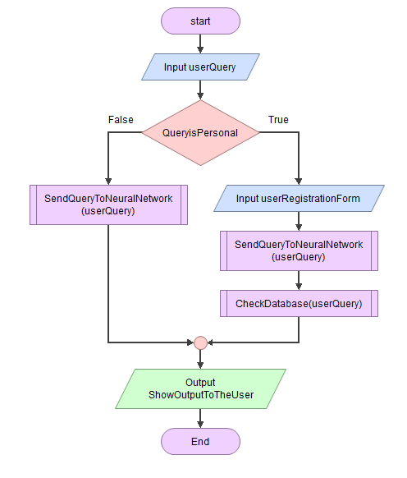

**Pseudocode**

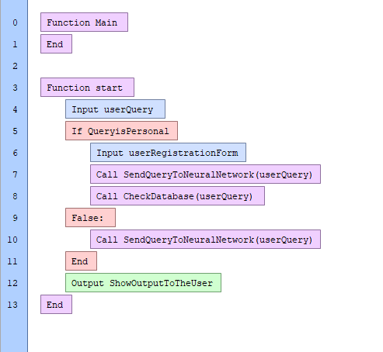

**6.0.2 Change Settings Component**

**FlowChart**

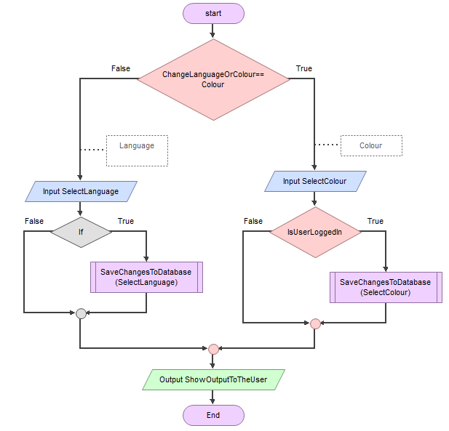

**Pseudocode**

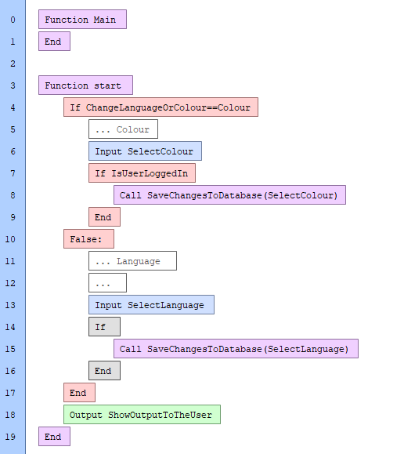

**6.0.2 Admin Setting Component**

**FlowChart**

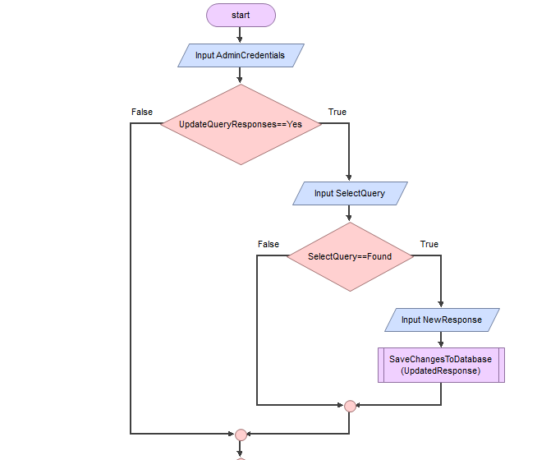

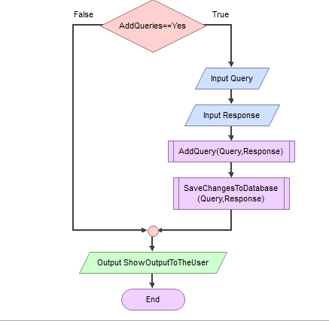

**Pseudocode**

